## UNIT-II

**TIME RESPONSE ANALYSIS**

We can analyze the response of the control systems in both the time domain and the frequency domain. We will discuss frequency response analysis of control systems in later chapters. Let us now discuss about the time response analysis of control systems.

What is Time Response?

If the output of control system for an input varies with respect to time, then it is called the **time response** of the control system. The time response consists of two parts.

* + Transient response
  + Steady state response

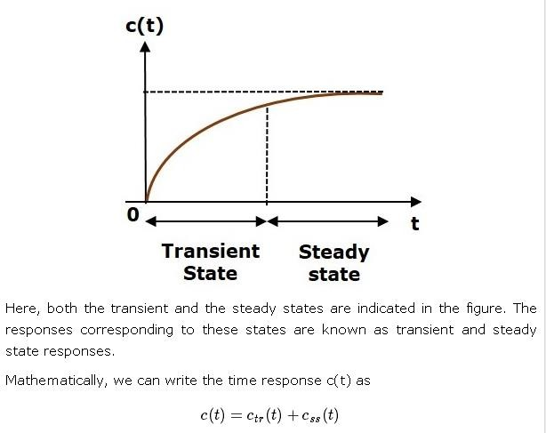The response of control system in time domain is shown in the following figure.

Where,

* + ctr(t) is the transient response
  + css(t) is the steady state response

## Transient Response

After applying input to the control system, output takes certain time to reach steady state. So, the output will be in transient state till it goes to a steady state. Therefore, the response of the control system during the transient state is known as **transient response**.

The transient response will be zero for large values of ‘t’. Ideally, this value of ‘t’ is infinity and practically, it is five times constant.

Mathematically, we can write it as



## Steady state Response

The part of the time response that remains even after the transient response has zero value for large values of ‘t’ is known as **steady state response**. This means, the transient response will be zero even during the steady state.

## Example

Let us find the transient and steady state terms of the time response of the control system

Here, the second term will be zero as **t** denotes infinity. So, this is the **transient term**. And the first term 10 remains even as **t** approaches infinity. So, this is the **steady state term**.

Standard Test Signals

The standard test signals are impulse, step, ramp and parabolic. These signals are used to know the performance of the control systems using time response of the output.

Unit Impulse Signal

A unit impulse signal, δ(t) is defined as

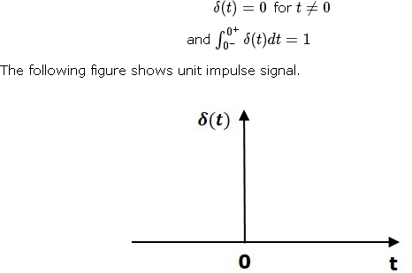

So, the unit impulse signal exists only at‘t’ is equal to zero. The area of this signal under small interval of time around‘t’ is equal to zero is one. The value of unit impulse signal is zero for all other values of‘t’.

## Unit Step Signal

A unit step signal, u(t) is defined as



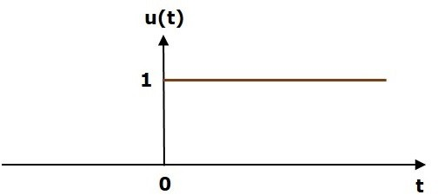Following figure shows unit step signal.

So, the unit step signal exists for all positive values of‘t’ including zero. And its value is one during this interval. The value of the unit step signal is zero for all negative values of‘t’.

Unit Ramp Signal

A unit ramp signal, r (t) is defined as

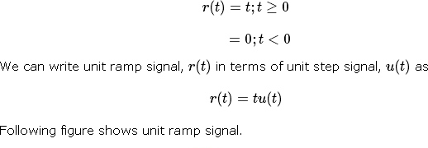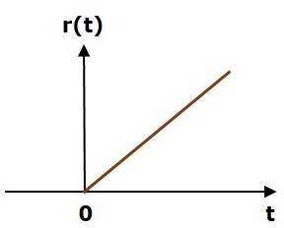

So, the unit ramp signal exists for all positive values of‘t’ including zero. And its value increases linearly with respect to‘t’ during this interval. The value of unit ramp signal is zero for all negative values of‘t’.

Unit Parabolic Signal

A unit parabolic signal, p(t) is defined as,

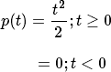

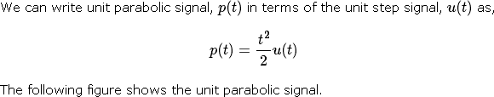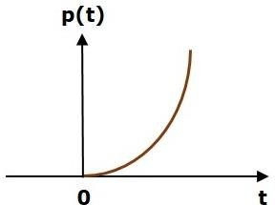

So, the unit parabolic signal exists for all the positive values of‘t’ including zero. And its value increases non-linearly with respect to‘t’ during this interval. The value of the unit parabolic signal is zero for all the negative values of‘t’.

In this chapter, let us discuss the time response of the first order system. Consider the following block diagram of the closed loop control system. Here, an open loop transfer function, 1/sT is connected with a unity negative feedback.

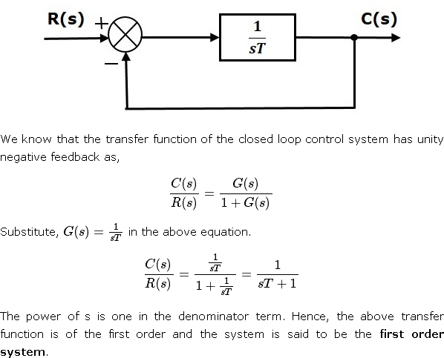

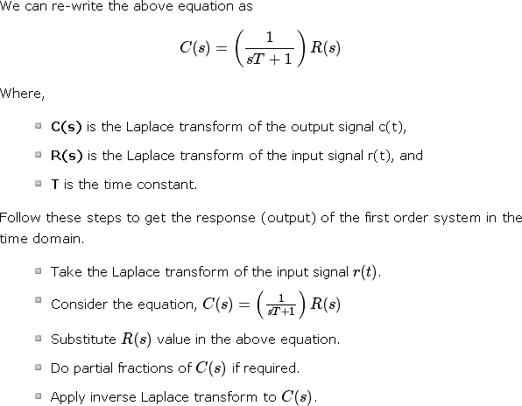

## Impulse Response of First Order System

Consider the **unit impulse signal** as an input to the first order system.

# So, r(t)=δ(t)

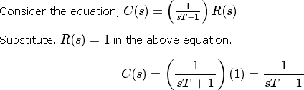Apply Laplace transform on both the sides. R(s) =1

Rearrange the above equation in one of the standard forms of Laplace transforms.



Applying Inverse Laplace Transform on both the sides,





The unit impulse response is shown in the following figure.

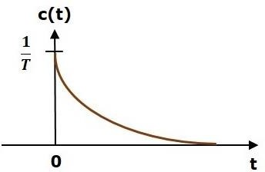

The **unit impulse response**, c(t) is an exponential decaying signal for positive values of ‘t’ and it is zero for negative values of ‘t’.

## Step Response of First Order System

Consider the **unit step signal** as an input to first order system. So, r(t)=u(t)

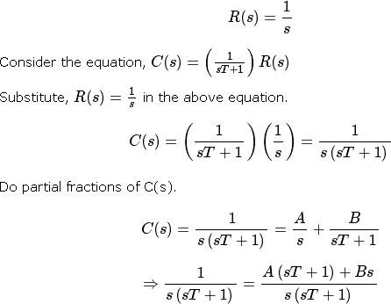

On both the sides, the denominator term is the same. So, they will get cancelled by each other. Hence, equate the numerator terms.

1=A(sT+1)+Bs

By equating the constant terms on both the sides, you will get A = 1. Substitute, A = 1 and equate the coefficient of the **s** terms on both the sides.

0=T+B

⇒B=−T

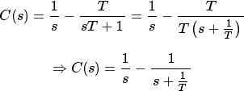Substitute, A = 1 and B = −T in partial fraction expansion of C(s)

Apply inverse Laplace transform on both the sides.



The **unit step response**, c(t) has both the transient and the steady state terms.

The transient term in the unit step response is -

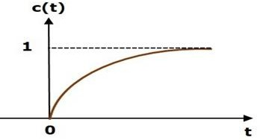The steady state term in the unit step response is – The following figure shows the unit step response

The value of the **unit step response, c(t)** is zero at t = 0 and for all negative values of t. It is gradually increasing from zero value and finally reaches to one in steady state. So, the steady state value depends on the magnitude of the input.

## Ramp Response of First Order System

Consider the **unit ramp signal** as an input to the first order system.

So,r(t)=t u(t)

Apply Laplace transform on both the sides.

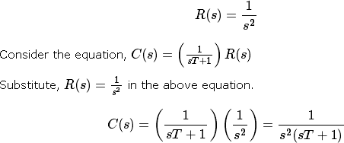

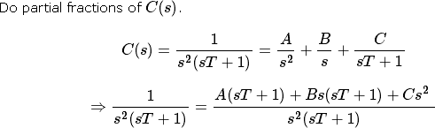

On both the sides, the denominator term is the same. So, they will get cancelled by each other. Hence, equate the numerator terms.

By equating the constant terms on both the sides, you will get A = 1. Substitute, A = 1 and equate the coefficient of the s terms on both the sides.

0=T+B⇒B=−T

Similarly, substitute B = −T and equate the coefficient of s2 terms on both the sides. You will get C=T2

Substitute A = 1, B = −T and C=T2 in the partial fraction expansion of C(s).

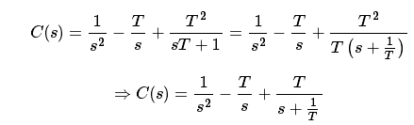

Apply inverse Laplace transform on both the sides.



The **unit ramp response**, c(t) has both the transient and the steady state terms. The transient term in the unit ramp response is

The steady state term in the unit ramp response is –



The figure below is the unit ramp response:

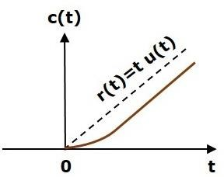

The **unit ramp response**, c(t) follows the unit ramp input signal for all positive values of t. But, there is a deviation of T units from the input signal.

## Parabolic Response of First Order System

Consider the **unit parabolic signal** as an input to the first order system.

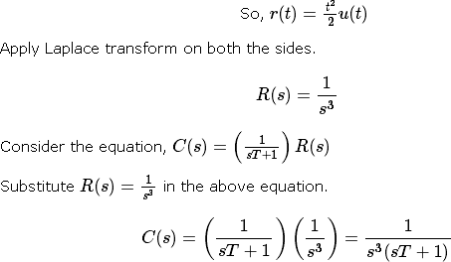\

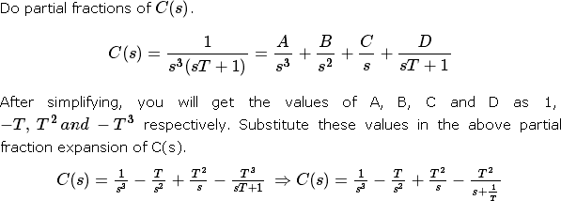

Apply inverse Laplace transform on both the sides.



The **unit parabolic response**, c(t) has both the transient and the steady state terms.

The transient term in the unit parabolic response is



The steady state term in the unit parabolic response is



From these responses, we can conclude that the first order control systems are not stable with the ramp and parabolic inputs because these responses go on increasing even at infinite amount of time. The first order control systems are stable with impulse and step inputs because these responses have bounded output. But, the impulse response doesn’t have steady state term. So, the step signal is widely used in the time domain for analyzing the control systems from their responses.

In this chapter, let us discuss the time response of second order system. Consider the following block diagram of closed loop control system. Here, an open loop transfer function, ω 2 / s(s+2δωn) is connected with a unity negative feedback.

n

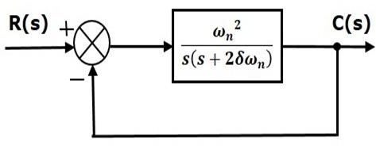

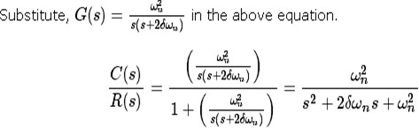

The power of ‘s’ is two in the denominator term. Hence, the above transfer function is of the second order and the system is said to be the **second order system**.

The characteristic equation is -



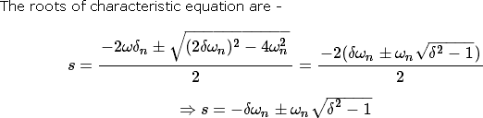b

* + The two roots are imaginary when δ = 0.
  + The two roots are real and equal when δ = 1.
  + The two roots are real but not equal when δ > 1.
  + The two roots are complex conjugate when 0 < δ < 1. We can write C(s) equation as,



Where,

* + **C(s)** is the Laplace transform of the output signal, c(t)
  + **R(s)** is the Laplace transform of the input signal, r(t)
  + **ωn** is the natural frequency
  + **δ** is the damping ratio.

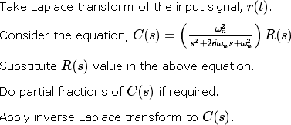Follow these steps to get the response (output) of the second order system in the time domain.

## Step Response of Second Order System

Consider the unit step signal as an input to the second order system.Laplace transform of the unit step signal is,

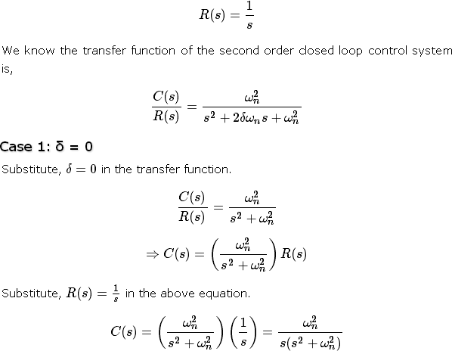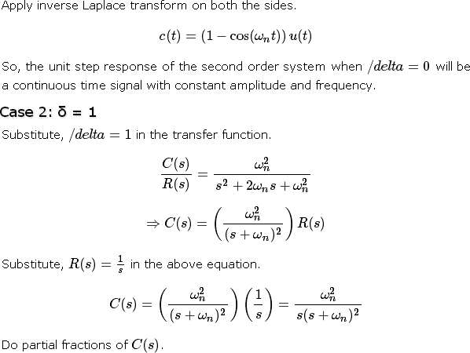

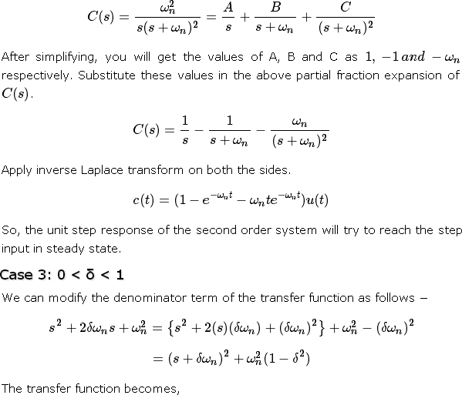

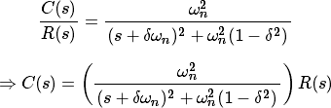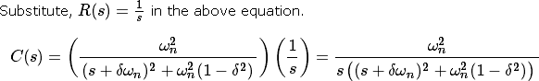

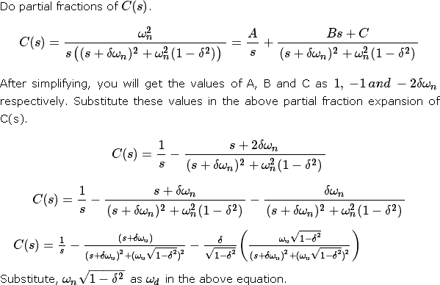

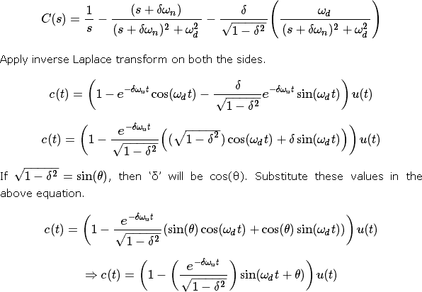

So, the unit step response of the second order system is having damped oscillations (decreasing amplitude) when ‘δ’ lies between zero and one.

Case 4: δ > 1

We can modify the denominator term of the transfer function as follows −

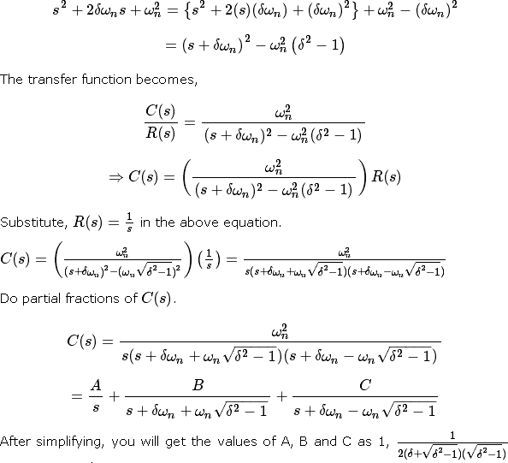

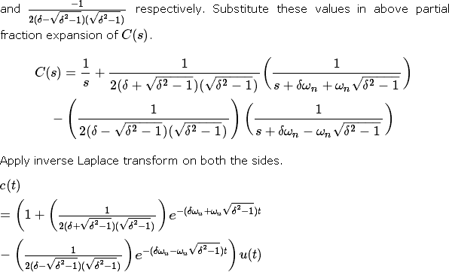

Since it is over damped, the unit step response of the second order system when δ > 1 will never reach step input in the steady state.

## Impulse Response of Second Order System

The **impulse response** of the second order system can be obtained by using any one of these two methods.

* + Follow the procedure involved while deriving step response by considering the value of R(s) as 1 instead of 1/s.
  + Do the differentiation of the step response.

The following table shows the impulse response of the second order system for 4 cases of the damping ratio.

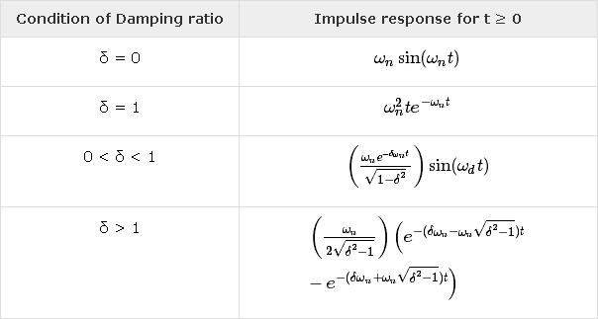

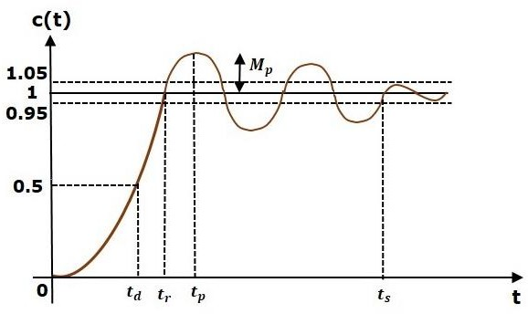In this chapter, let us discuss the time domain specifications of the second order system. The step response of the second order system for the underdamped case is shown in the following figure.

All the time domain specifications are represented in this figure. The response up to the settling time is known as transient response and the response after the settling time is known as steady state response.

## Delay Time

It is the time required for the response to reach **half of its final value** from the zero instant. It is denoted by tdtd.

Consider the step response of the second order system for t ≥ 0, when ‘δ’ lies between zero and one.

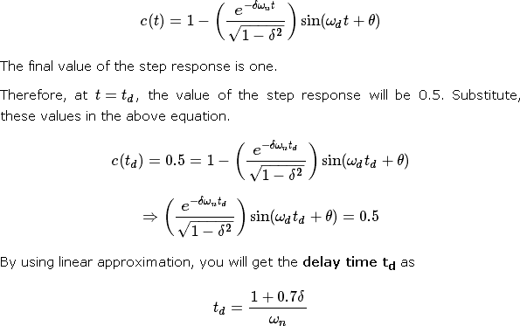

## Rise Time

It is the time required for the response to rise from **0% to 100% of its final value**. This is applicable for the **under-damped systems**. For the over-damped systems, consider the duration from 10% to 90% of the final value. Rise time is denoted by **tr**.

At t = t1 = 0, c(t) = 0.

We know that the final value of the step response is one.Therefore, at t=t2, the value of step response is one. Substitute, these values in the following equation.

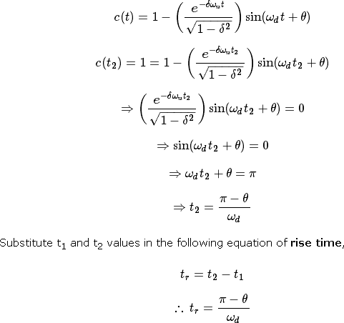

From above equation, we can conclude that the rise time tr and the damped frequency ωd are inversely proportional to each other.

## Peak Time

It is the time required for the response to reach the **peak value** for the first time. It is denoted by tp. At t=tp the first derivate of the response is zero.

We know the step response of second order system for under-damped case is

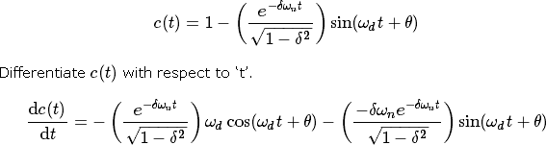

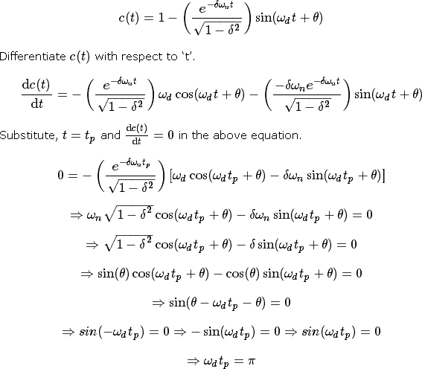

From the above equation, we can conclude that the peak time tp and the damped frequency ωd are inversely proportional to each other.

## Peak Overshoot

Peak overshoot **Mp** is defined as the deviation of the response at peak time from the final value of response. It is also called the **maximum overshoot**.

Mathematically, we can write it as

# Mp=c(tp) − c(∞)

Where,c(tp) is the peak value of the response, c(∞) is the final (steady state) value of the response.

At t=tp, the response c(t) is -

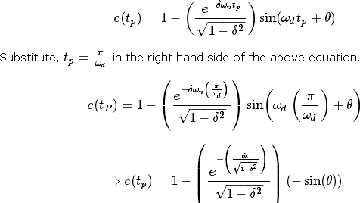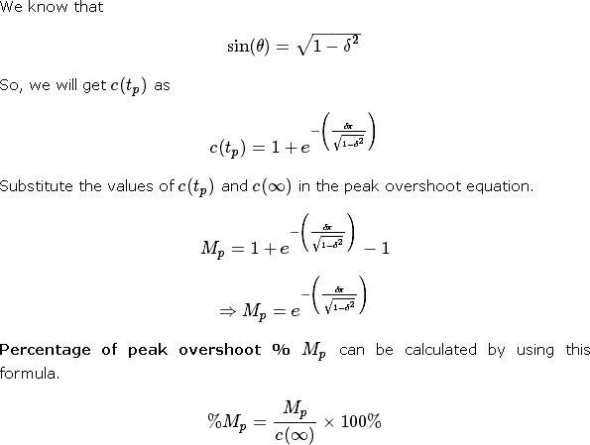

From the above equation, we can conclude that the percentage of peak overshoot %Mp will decrease if the damping ratio δ increases.

## Settling time

It is the time required for the response to reach the steady state and stay within the specified tolerance bands around the final value. In general, the tolerance bands are 2% and 5%. The settling time is denoted by ts.

The settling time for 5% tolerance band is –



The settling time for 2% tolerance band is –



Where, τ is the time constant and is equal to 1/δωn.

* + Both the settling time ts and the time constant τ are inversely proportional to the damping ratio δ.
  + Both the settling time ts and the time constant τ are independent of the system gain. That means even the system gain changes, the settling time ts and time constant τ will never change.

## Example

Let us now find the time domain specifications of a control system having the closed loop transfer function when the unit step signal is applied as an input to this control system.

We know that the standard form of the transfer function of the second order closed loop control system as



By equating these two transfer functions, we will get the un-damped natural frequency ωn as 2 rad/sec and the damping ratio δ as 0.5.

We know the formula for damped frequency ωd as

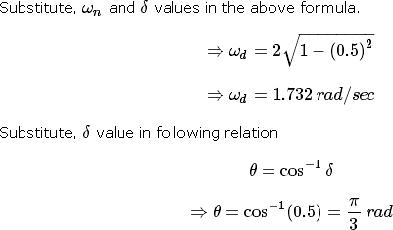

Substitute the above necessary values in the formula of each time domain specification and simplify in order to get the values of time domain specifications for given transfer function.

The following table shows the formulae of time domain specifications, substitution of necessary values and the final values

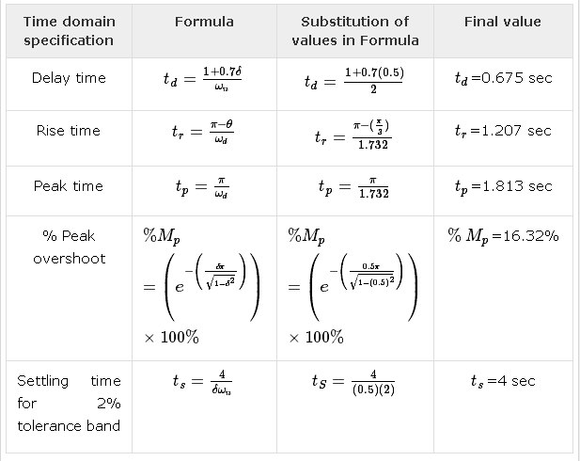

The deviation of the output of control system from desired response during steady state is known as **steady state error**. It is represented as ess. We can find steady state error using the final value theorem as follows.



Where,

E(s) is the Laplace transform of the error signal, e(t)

Let us discuss how to find steady state errors for unity feedback and non-unity feedback control systems one by one.

## Steady State Errors for Unity Feedback Systems

Consider the following block diagram of closed loop control system, which is having unity negative feedback.

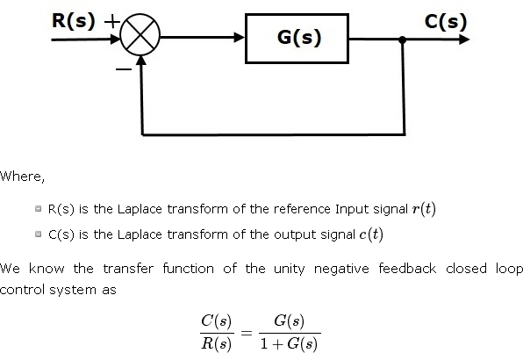

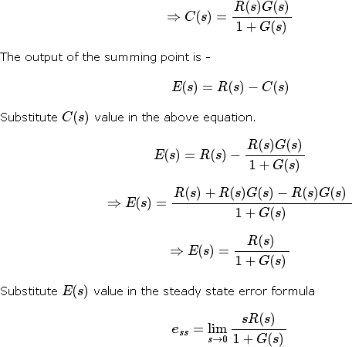

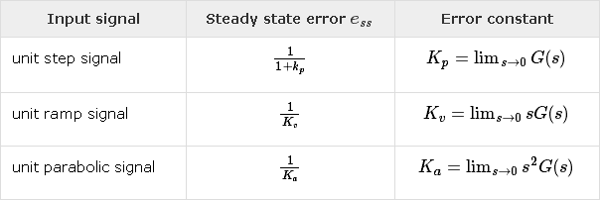The following table shows the steady state errors and the error constants for standard input signals like unit step, unit ramp & unit parabolic signals.

Where, Kp, Kv and Ka are position error constant, velocity error constant and acceleration error constant respectively.

**Note** − If any of the above input signals has the amplitude other than unity, then multiply corresponding steady state error with that amplitude.

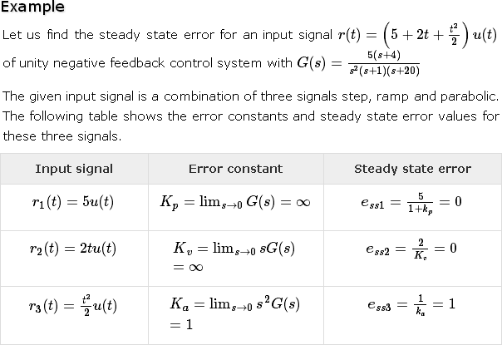**Note** − We can’t define the steady state error for the unit impulse signal because, it exists only at origin. So, we can’t compare the impulse response with the unit impulse input as **t** denotes infinity

We will get the overall steady state error, by adding the above three steady state errors.

ess = ess1+ess2+ess3

⇒ess=0+0+1=1⇒ess=0+0+1=1

Therefore, we got the steady state error ess as **1** for this example.

## Steady State Errors for Non-Unity Feedback Systems

Consider the following block diagram of closed loop control system, which is having non unity negative feedback.

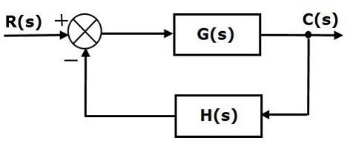

We can find the steady state errors only for the unity feedback systems. So, we have to convert the non-unity feedback system into unity feedback system. For this, include one unity positive feedback path and one unity negative feedback path in the above block diagram. The new block diagram looks like as shown below.

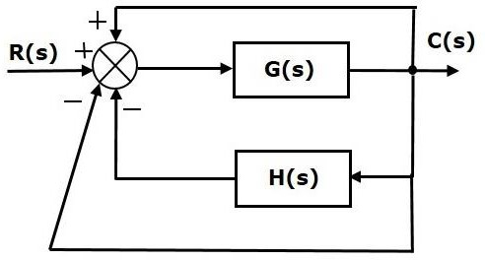

Simplify the above block diagram by keeping the unity negative feedback as it is. The following is the simplified block diagram

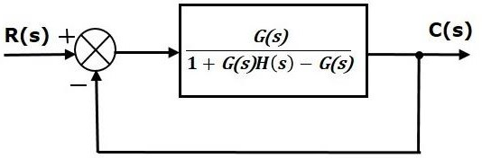

This block diagram resembles the block diagram of the unity negative feedback closed loop control system. Here, the single block is having the transfer function G(s) / [ 1+G(s)H(s)−G(s)] instead of G(s).You can now calculate the steady state errors by using steady state error formula given for the unity negative feedback systems.

**Note** − It is meaningless to find the steady state errors for unstable closed loop systems. So, we have to calculate the steady state errors only for closed loop stable systems. This means we need to check whether the control system is stable or not before finding the steady state errors. In the next chapter, we will discuss the concepts-related stability.

The various types of controllers are used to improve the performance of control systems. In this chapter, we will discuss the basic controllers such as the proportional, the derivative and the integral controllers.

## Proportional Controller

The proportional controller produces an output, which is proportional to error signal.

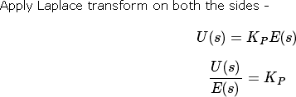

Therefore, the transfer function of the proportional controller is KPKP.

Where,

U(s) is the Laplace transform of the actuating signal u(t) E(s) is the Laplace transform of the error signal e(t)

KP is the proportionality constant

The block diagram of the unity negative feedback closed loop control system along with the proportional controller is shown in the following figure.

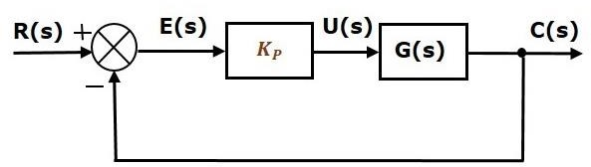

## Derivative Controller

The derivative controller produces an output, which is derivative of the error signal.

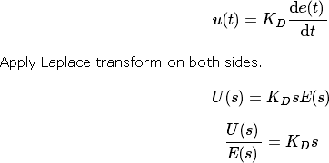

Therefore, the transfer function of the derivative controller is KDs. Where, KD is the derivative constant.

The block diagram of the unity negative feedback closed loop control system along with the derivative controller is shown in the following figure.

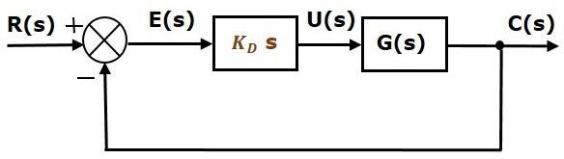

The derivative controller is used to make the unstable control system into a stable one.

## Integral Controller

The integral controller produces an output, which is integral of the error signal.

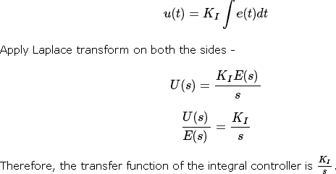

Where, KIKI is the integral constant.

The block diagram of the unity negative feedback closed loop control system along with the integral controller is shown in the following figure.

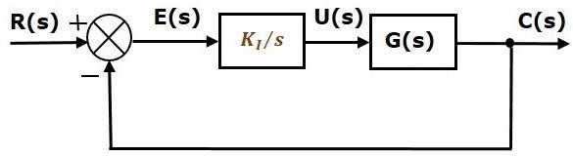

The integral controller is used to decrease the steady state error. Let us now discuss about the combination of basic controllers.

## Proportional Derivative (PD) Controller

The proportional derivative controller produces an output, which is the combination of the outputs of proportional and derivative controllers.

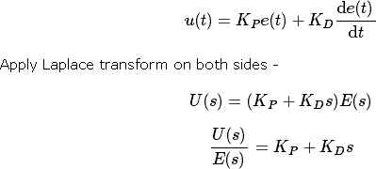

Therefore, the transfer function of the proportional derivative controller is KP+KDs.

The block diagram of the unity negative feedback closed loop control system along with the proportional derivative controller is shown in the following figure.

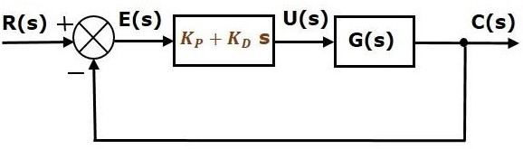

The proportional derivative controller is used to improve the stability of control system without affecting the steady state error.

## Proportional Integral (PI) Controller

The proportional integral controller produces an output, which is the combination of outputs of the proportional and integral controllers.

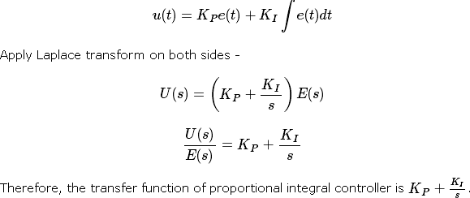

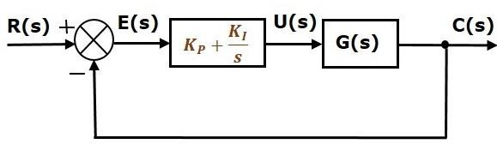The block diagram of the unity negative feedback closed loop control system along with the proportional integral controller is shown in the following figure.

The proportional integral controller is used to decrease the steady state error without affecting the stability of the control system.

## Proportional Integral Derivative (PID) Controller

The proportional integral derivative controller produces an output, which is the combination of the outputs of proportional, integral and derivative controllers.

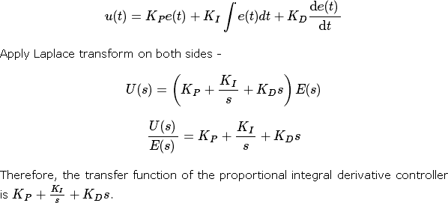

The block diagram of the unity negative feedback closed loop control system along with the proportional integral derivative controller is shown in the following figure.

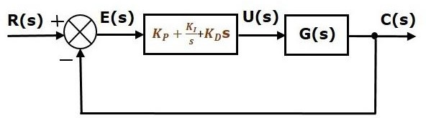

**STABILITY ANALYSIS IN S-DOMAIN**

Stability is an important concept. In this chapter, let us discuss the stability of system and types of systems based on stability.

What is Stability?

A system is said to be stable, if its output is under control. Otherwise, it is said to be unstable. A **stable system** produces a bounded output for a given bounded input.

The following figure shows the response of a stable system.

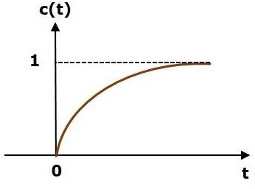

This is the response of first order control system for unit step input. This response has the values between 0 and 1. So, it is bounded output. We know that the unit step signal has the value of one for all positive values of **t** including zero. So, it is bounded input. Therefore, the first order control system is stable since both the input and the output are bounded.

Types of Systems based on Stability

We can classify the systems based on stability as follows.

* + Absolutely stable system
  + Conditionally stable system
  + Marginally stable system

Absolutely Stable System

If the system is stable for all the range of system component values, then it is known as the **absolutely stable system**. The open loop control system is absolutely stable if all the poles of the open loop transfer function present in left half of **‘s’ plane**. Similarly, the closed loop control system is absolutely stable if all the poles of the closed loop transfer function present in the left half of the ‘s’ plane.

Conditionally Stable System

If the system is stable for a certain range of system component values, then it is known as **conditionally stable system**.

Marginally Stable System

If the system is stable by producing an output signal with constant amplitude and constant frequency of oscillations for bounded input, then it is known as **marginally stable system**. The open loop control system is marginally stable if any two poles of the open loop transfer function is present on the imaginary axis. Similarly, the closed loop control system is marginally stable if any two poles of the closed loop transfer function is present on the imaginary axis.

n this chapter, let us discuss the stability analysis in the **‘s’** domain using the RouthHurwitz stability criterion. In this criterion, we require the characteristic equation to find the stability of the closed loop control systems.

## Routh-Hurwitz Stability Criterion

Routh-Hurwitz stability criterion is having one necessary condition and one sufficient condition for stability. If any control system doesn’t satisfy the necessary condition, then we can say that the control system is unstable. But, if the control system satisfies the necessary condition, then it may or may not be stable. So, the sufficient condition is helpful for knowing whether the control system is stable or not.

## Necessary Condition for Routh-Hurwitz Stability

The necessary condition is that the coefficients of the characteristic polynomial should be positive. This implies that all the roots of the characteristic equation should have negative real parts.

Consider the characteristic equation of the order ‘n’ is -



Note that, there should not be any term missing in the **nth** order characteristic equation. This means that the **nth** order characteristic equation should not have any coefficient that is of zero value.

## Sufficient Condition for Routh-Hurwitz Stability

The sufficient condition is that all the elements of the first column of the Routh array should have the same sign. This means that all the elements of the first column of the Routh array should be either positive or negative.

## Routh Array Method

If all the roots of the characteristic equation exist to the left half of the ‘s’ plane, then the control system is stable. If at least one root of the characteristic equation exists to the right half of the ‘s’ plane, then the control system is unstable. So, we have to find the roots of the characteristic equation to know whether the control system is stable or unstable. But, it is difficult to find the roots of the characteristic equation as order increases.

So, to overcome this problem there we have the **Routh array method**. In this method, there is no need to calculate the roots of the characteristic equation. First formulate the Routh table and find the number of the sign changes in the first column of the Routh table. The number of sign changes in the first column of the Routh table gives the number of roots of characteristic equation that exist in the right half of the ‘s’ plane and the control system is unstable.

Follow this procedure for forming the Routh table.

* + Fill the first two rows of the Routh array with the coefficients of the characteristic polynomial as mentioned in the table below. Start with the coefficient of sn and continue up to the coefficient of s0.
  + Fill the remaining rows of the Routh array with the elements as mentioned in the table below. Continue this process till you get the first column element of **row** s0s0 is an. Here, an is the coefficient of s0 in the characteristic polynomial.

**Note** − If any row elements of the Routh table have some common factor, then you can divide the row elements with that factor for the simplification will be easy.

The following table shows the Routh array of the nth order characteristic polynomial.

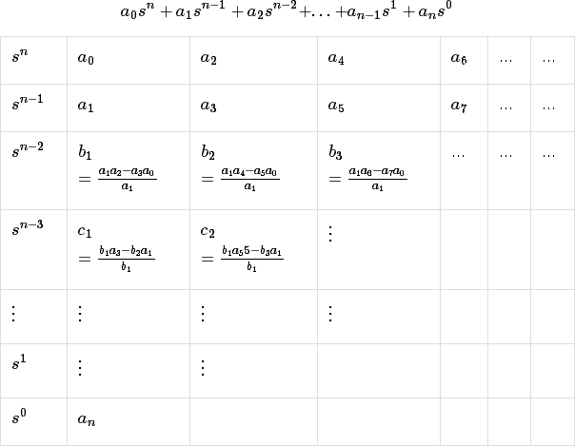

## Example

Let us find the stability of the control system having characteristic equation,



**Step 1** − Verify the necessary condition for the Routh-Hurwitz stability. All the coefficients of the characteristic polynomial,

are positive. So, the control system satisfies the necessary

condition.

**Step 2** − Form the Routh array for the given characteristic polynomial.

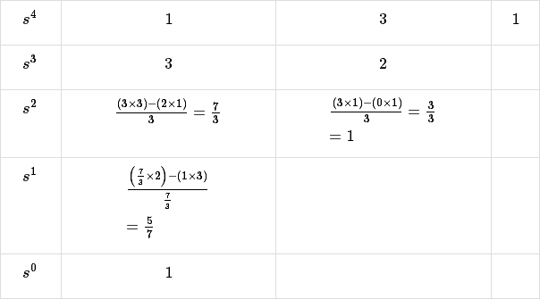

**Step 3** − Verify the sufficient condition for the Routh-Hurwitz stability.

All the elements of the first column of the Routh array are positive. There is no sign change in the first column of the Routh array. So, the control system is stable.

## Special Cases of Routh Array

We may come across two types of situations, while forming the Routh table. It is difficult to complete the Routh table from these two situations.

The two special cases are −

* + The first element of any row of the Routh’s array is zero.
  + All the elements of any row of the Routh’s array are zero.

Let us now discuss how to overcome the difficulty in these two cases, one by one.

## First Element of any row of the Routh’s array is zero

If any row of the Routh’s array contains only the first element as zero and at least one of the remaining elements have non-zero value, then replace the first element with a small positive integer, ϵ. And then continue the process of completing the Routh’s table. Now, find the number of sign changes in the first column of the Routh’s table by substituting ϵϵ tends to zero.

## Example

Let us find the stability of the control system having characteristic equation,



**Step 1** − Verify the necessary condition for the Routh-Hurwitz stability. All the coefficients of the characteristic polynomial,

are positive. So, the control system satisfied the

necessary condition.

**Step 2** − Form the Routh array for the given characteristic polynomial.

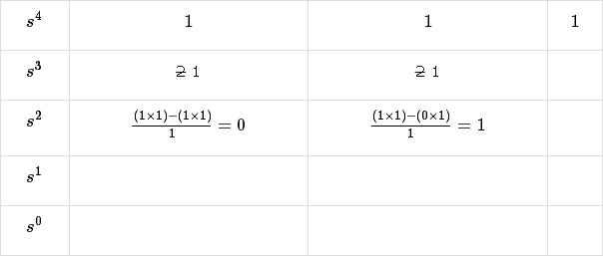

The row s3 elements have 2 as the common factor. So, all these elements are divided by 2. **Special case (i)** − Only the first element of row s2 is zero. So, replace it by ϵ and continue the process of completing the Routh table.

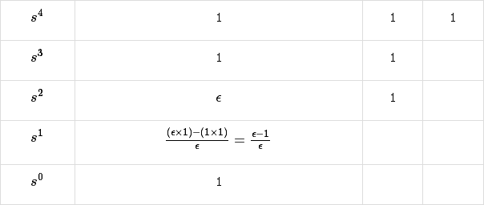

**Step 3** − Verify the sufficient condition for the Routh-Hurwitz stability. As ϵ tends to zero, the Routh table becomes like this.

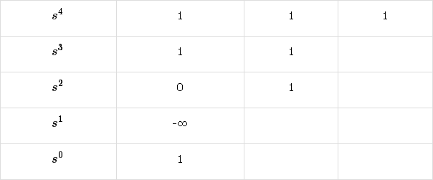There are two sign changes in the first column of Routh table. Hence, the control system is unstable.

## All the Elements of any row of the Routh’s array are zero

In this case, follow these two steps −

* + Write the auxilary equation, A(s) of the row, which is just above the row of zeros.
  + Differentiate the auxiliary equation, A(s) with respect to s. Fill the row of zeros with these coefficients.

## Example

Let us find the stability of the control system having characteristic equation,



**Step 1** − Verify the necessary condition for the Routh-Hurwitz stability.

All the coefficients of the given characteristic polynomial are positive. So, the control system satisfied the necessary condition.

**Step 2** − Form the Routh array for the given characteristic polynomial.

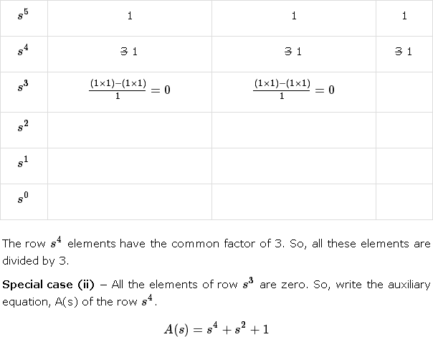

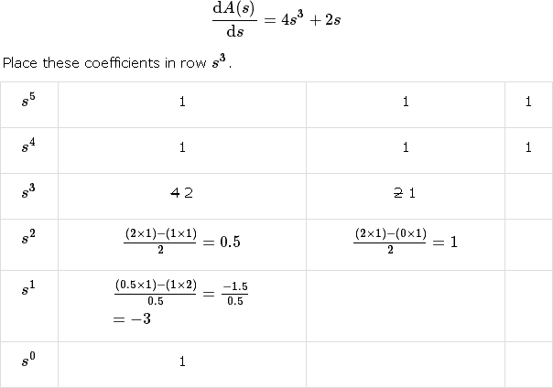

**Step 3** − Verify the sufficient condition for the Routh-Hurwitz stability.

There are two sign changes in the first column of Routh table. Hence, the control system is unstable.

In the Routh-Hurwitz stability criterion, we can know whether the closed loop poles are in on left half of the ‘s’ plane or on the right half of the ‘s’ plane or on an imaginary axis. So, we can’t find the nature of the control system. To overcome this limitation, there is a technique known as the root locus.

## Root locus Technique

In the root locus diagram, we can observe the path of the closed loop poles. Hence, we can identify the nature of the control system. In this technique, we will use an open loop transfer function to know the stability of the closed loop control system.

## Basics of Root Locus

The Root locus is the locus of the roots of the characteristic equation by varying system gain K from zero to infinity.

We know that, the characteristic equation of the closed loop control system is

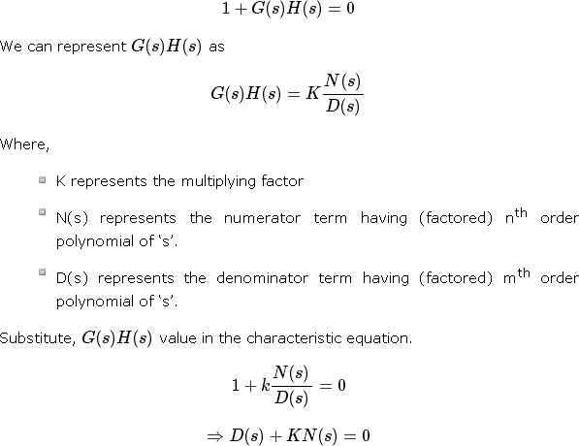

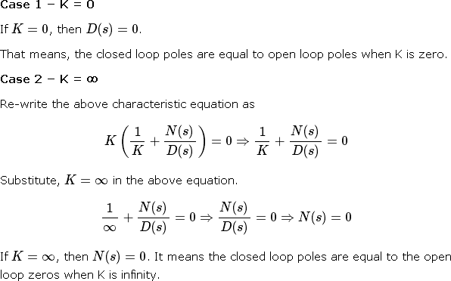

From above two cases, we can conclude that the root locus branches start at open loop poles and end at open loop zeros.

## Angle Condition and Magnitude Condition

The points on the root locus branches satisfy the angle condition. So, the angle condition is used to know whether the point exist on root locus branch or not. We can find the value of K for the points on the root locus branches by using magnitude condition. So, we can use the magnitude condition for the points, and this satisfies the angle condition.

Characteristic equation of closed loop control system is

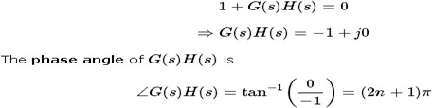

The **angle condition** is the point at which the angle of the open loop transfer function is an odd multiple of 1800.

Magnitude of G(s)H(s)G(s)H(s) is –



The magnitude condition is that the point (which satisfied the angle condition) at which the magnitude of the open loop transfer function is one.

The **root locus** is a graphical representation in s-domain and it is symmetrical about the real axis. Because the open loop poles and zeros exist in the s-domain having the values either as real or as complex conjugate pairs. In this chapter, let us discuss how to construct (draw) the root locus.

Rules for Construction of Root Locus

Follow these rules for constructing a root locus.

**Rule 1** − Locate the open loop poles and zeros in the‘s’ plane.

**Rule 2** − Find the number of root locus branches.

We know that the root locus branches start at the open loop poles and end at open loop zeros. So, the number of root locus branches **N** is equal to the number of finite open loop poles **P** or the number of finite open loop zeros **Z**, whichever is greater.

Mathematically, we can write the number of root locus branches **N** as

N=P if P≥Z N=Z if P<Z

**Rule 3** − Identify and draw the **real axis root locus branches**.

If the angle of the open loop transfer function at a point is an odd multiple of 1800, then that point is on the root locus. If odd number of the open loop poles and zeros exist to the left side of a point on the real axis, then that point is on the root locus branch. Therefore, the branch of points which satisfies this condition is the real axis of the root locus branch.

**Rule 4** − Find the centroid and the angle of asymptotes.

* + If P=Z, then all the root locus branches start at finite open loop poles and end at finite open loop zeros.
  + If P>Z, then Z number of root locus branches start at finite open loop poles and end at finite open loop zeros and P−Z number of root locus branches start at finite open loop poles and end at infinite open loop zeros.
  + If P<Z , then P number of root locus branches start at finite open loop poles and end at finite open loop zeros and Z−P number of root locus branches start at infinite open loop poles and end at finite open loop zeros.

So, some of the root locus branches approach infinity, when P≠Z. Asymptotes give the direction of these root locus branches. The intersection point of asymptotes on the real axis is known as **centroid**.

We can calculate the **centroid α** by using this formula,

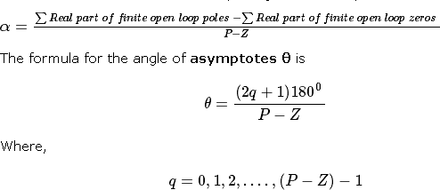

**Rule 5** − Find the intersection points of root locus branches with an imaginary axis.

We can calculate the point at which the root locus branch intersects the imaginary axis and the value of **K** at that point by using the Routh array method and special **case (ii)**.

* + If all elements of any row of the Routh array are zero, then the root locus branch intersects the imaginary axis and vice-versa.
  + Identify the row in such a way that if we make the first element as zero, then the elements of the entire row are zero. Find the value of **K** for this combination.
  + Substitute this **K** value in the auxiliary equation. You will get the intersection point of the root locus branch with an imaginary axis.

**Rule 6** − Find Break-away and Break-in points.

* + If there exists a real axis root locus branch between two open loop poles, then there will be a **break-away point** in between these two open loop poles.
  + If there exists a real axis root locus branch between two open loop zeros, then there will be a **break-in point** in between these two open loop zeros.

**Note** − Break-away and break-in points exist only on the real axis root locus branches. Follow these steps to find break-away and break-in points.

* + Write K in terms of s from the characteristic equation 1+G(s)H(s)=0.
  + Differentiate K with respect to s and make it equal to zero. Substitute these values of ss in the above equation.
  + The values of ss for which the K value is positive are the **break points**.

**Rule 7** − Find the angle of departure and the angle of arrival.

The Angle of departure and the angle of arrival can be calculated at complex conjugate open loop poles and complex conjugate open loop zeros respectively.

The formula for the **angle of departure** ϕd is

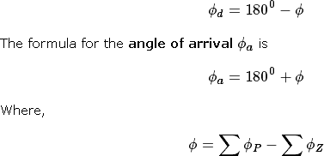

Example

Let us now draw the root locus of the control system having open loop transfer

function,

**Step 1** − The given open loop transfer function has three poles at s = 0,

s = -1, s = -5. It doesn’t have any zero. Therefore, the number of root locus branches is equal to the number of poles of the open loop transfer function.

N=P=3

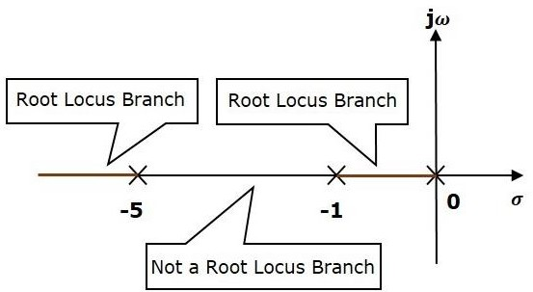

The three poles are located are shown in the above figure. The line segment between s=−1, and s=0 is one branch of root locus on real axis. And the other branch of the root locus on the real axis is the line segment to the left of s=−5.

**Step 2** − We will get the values of the centroid and the angle of asymptotes by using the given formulae.

Centroid

The angle of asymptotes are

The centroid and three asymptotes are shown in the following figure.

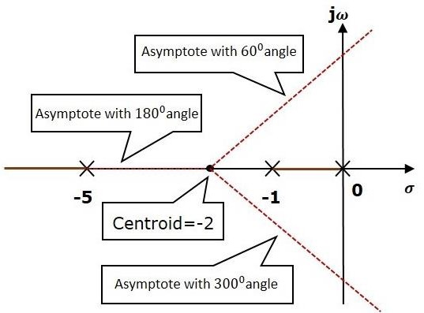

**Step 3** − Since two asymptotes have the angles of 600600 and 30003000, two root locus branches intersect the imaginary axis. By using the Routh array method and special case(ii),

the root locus branches intersects the imaginary axis at and

There will be one break-away point on the real axis root locus branch between the poles s

=−1 and s=0. By following the procedure given for the calculation of break-away point, we will get it as s =−0.473.

The root locus diagram for the given control system is shown in the following figure.

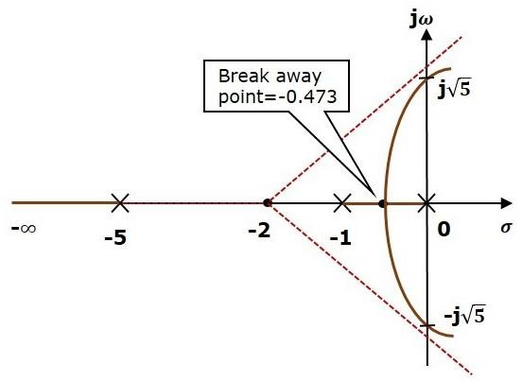

In this way, you can draw the root locus diagram of any control system and observe the movement of poles of the closed loop transfer function.

From the root locus diagrams, we can know the range of K values for different types of damping.

Effects of Adding Open Loop Poles and Zeros on Root Locus

The root locus can be shifted in **‘s’ plane** by adding the open loop poles and the open loop zeros.

* + If we include a pole in the open loop transfer function, then some of root locus branches will move towards right half of ‘s’ plane. Because of this, the damping ratio δ decreases. Which implies, damped frequency ωd increases and the time domain specifications like delay time td, rise time tr and peak time tp decrease. But, it effects the system stability.
  + If we include a zero in the open loop transfer function, then some of root locus branches will move towards left half of ‘s’ plane. So, it will increase the control system stability. In this case, the damping ratio δ increases. Which implies, damped frequency ωd decreases and the time domain specifications like delay time td, rise time tr and peak time tp increase.

So, based on the requirement, we can include (add) the open loop poles or zeros to the transfer function.

